ARM 7 ARCHITECTURE
- The ARM 7 Core supports __________ for memory organisation &access , while _________ for ISA.
- The ARM 7 Core is 32-bit Core , which can be named so because of it’s _______ processing capability.
- Size of the Address BUS for ARM 7 Core is ________ ,so it address _________ of memory, with and address range ____________________ to _________________.
- The size of the data bus for ARM 7 Core is __________, and it supports aligned memory access, in which the addressable memory is distributed into ___ memory chips, each of 8bit/byte capacity per memory unit/location.
- For the above mentioned scenario, if the memory chips are labelled as bank0,bank1,bank2,bank3 , as figure given below:

 | 0x00000003 |  | 0x00000002 |  | 0x00000001 |  | 0x00000000
 | 0x00000007 |  | 0x00000006 |  | 0x00000005 |  | 0x00000004
 | 0x0000000B |  | 0x0000000A |  | 0x00000009 |  | 0x00000008
 | 0x0000000F |  | 0x0000000D |  | 0x0000000D |  | 0x0000000C
Byte3 | Bank 3 | Byte2 | Bank 2 | Byte1 | Bank 1 | Byte0 | Bank 0

A Byte value can be stored/loaded from any random location in the least clock cycle. (True/False)
A Halfword must be stored/loaded from location which is divisible by 2, int the least clock cylces. (True/False)
A Word must be stored/loaded from location which is divisible by 4,in the least clock cycles. (True/False)
Assume a float value of 5.7 in stored from memory location starting at 0x00000008 in little endian order, then the byte value at location 0x0000000B would be _______.
- The ARM 7 Core Supports ______ modes of operations , among which _______ are previleged & _______ is non previleged.
- The ARM 7 Core Supports ______ modes.
- The ARM 7 Core Supports ______ sources of interrupts to it.
- Map the operating modes of ARM 7 core with their usage.
Operating Mode Used For
------------------------ -----------------------------------------------------------------------
USR Can be invoked by programmer
FIQ When undefined instruction is encountered
IRQ Default mode after reset
SVC Whenever memory access fails
ABT When high priority interrupt occurs
UND When low priority interrupt occurs
SYS Normal Operating mode

- The ARM 7 supports ______ core registers in which not more than _____ core registers can be accessed in any one of the modes of operation.
- The register file refers to the collection of ______ (visible/invisible) core registers, namely register _____ _____ .
- ARM 7 features _______ code density ,which implies its ISA support ______ sets of instructions namely __________________ an 32-bit ISA instruction & _____________________ a 16-bit ISA.
- Load and Store multiple instructions maximize ____________ throughput.
- All THUMB instructions are of _________ size.
- What is expansion for MAC unit on ARM7.
- ____________ data type of C language in ARM7 can be stored at any memory address.
- ____________ data type of C language in ARM7 must be 16-bit aligned.
ARM 7 ARCHITECTURE Cont’d
- ____________ data types of C language in in ARM7 must be 32-bit aligned.
- The __________ is comprised of a CPU core with built-in peripheral modules, such as a programmable
general-purpose timer, programmable interrupt controller, DMA controller, Ethernet,
BlueTooth , WIFI, USB, modules & possibly more.
- Micro processor
- Micro controller
- DSP/DIP/FPU
- SoC processor

- Such a self-contained ________ design allows these embedded processors to be used to build a variety of embedded applications without needing additional external peripheral devices, thus reducing the overall cost and size of the final product.

- Micro processor
- Micro controller
- DSP/DIP/FPU
- SoC processor

- ARM 7 Core is not pure RISC, & deviations are all except
- Variable cycle execution for certain instruction
- Support for Inline Barrel Shifter & MAC Unit for Instructions Fusion
- Support of THUMB ISA
- Support for Conditional Execution to replace Conditional Branching Operations
- Support for DSP/DIP/FPU

- Embedded processors is/are available in class(es) as
- One class which focuses on size, power consumption & price
- One class which focuses on performances
- One class which on size, power consumption , price & performance.
- All of the above.

- The THUMB ISA is ______________ form of the ARM ISA. And All ARM Instruction don’t have ____________
Form as a one to one mapping.
- ________________ registers for ARM 7 Core are special registers in the register file.
- The R14 register is referred to as a _______________ in the ARM 7 Core.
- The ___ to ___ bits in the CPSR register are ARM’s Mode of Operation selection bits.
- There are _______ condition codes for ARM ISA.
- Which among the below 8bits hex numbers are not valid for operating mode in CPSR register.
- 0x10 B. 0x11 C. 0x12 D. 0x13
E. 0x14 F. 0x17 G. 0x1B H. 0x1F
- Arrange the following blocks/units in arm 7 core from top to bottom :
MAC, Address Register , ALU, Sign Extend, Register File,Barrel Shifter
- The barrel shifter in ARM is used for __________________________ of copy of information available in one of the register’s of the register file, before it’s value is given the ALU, for the next level processing along with another register with respect to the ALU .
- _____________ unit in the core pre shifts copy of operand available in one register of the register file before giving it to the ALU for processing with another operand available in another register of the register file.
- ARM 7 incorporates ___________ of on-chip hardware debug technologies name JTAG,ETM,RTM(Real Time Monitor).
- The processor mode determines which ____________ are active and the access rights to the cpsr(flag) register itself.
- A _______ mode i.e. ________ modes allows full read-write access to the cpsr.

ARM 7 ARCHITECTURE Cont’d
- A ________________ mode i.e. only _______ mode allows read access to the control field in the CPSR (flag) register, but still allows full read-write access to the condition flags.

- _____________the normal mode in which all user programs are executed.
- _____________the only non-privileged mode.
- __________ mode has limited access to flags in CPSR flag register.
- _____________ mode is entered when a high priority interrupt occurs through nFIQ pin of the ARM 7 core processor.
- In ________ mode the ISR executes with minimum latency(delay) due less context switching(saving/pushing & retrieving/popping) time.
- Nesting of interrupts are disabled in ______ mode
- _________ mode is the normal interrupt mode and is invoked when a low priority interrupt occurs on the nIRQ pin of the ARM 7 Core processor.
- ARM 7 Core enters ______________ mode on reset/power up.
- ______________ mode is used to execute the BIOS/Bootloader Program.
- ______________mode is generally the mode that an operating system kernel operates in.
- ______________ mode can also be invoked by the programmer by SWI (Software Interrupt) Instruction.
- ___________ mode is entered when an unsuccessful attempt is made to access a memory location
- ___________ mode is entered when the processor encounters an instruction that is undefined or not supported by the implementation
- Co-processors connected to ARM7 processor will operate in ______________ mode
- ___________ mode is the privileged version of the User Mode.
- The User Program can invoke __________ mode to gain full control (read-write) over CPSR.
- The abbreviation ”CPSR” for CPSR register stands for ____________________________________________.
- The CPSR register is _____ bit ___________(general/special) purpose _________ register.
- It has ______ fields ______ bit wide , name Control,Extension,Status,Flags.
- The Control Fields spans bit ___ to bit ____.
- The Extension Fields spans bit ___ to ____.
- The Status Field spans bit ____ to ____.
- The Flags Fields spans bit ____ to ____, which the arithematic flags are _____ bits.
- The register file of system & user mode are common resource. (True/False)
- The banked registers for FIQ Mode are totally ________ in number, from ______ to ______ , & _______ .
- The Processor Modes IRQ,SVC,ABT & UND each have ______ number of banked registers, ______ ,______ ,&_____ .
- The total 37 ARM7 Core register can be accounted as follows
System & User Modes ________ number of common registers
FIQ Mode ________ number of banked registers.
IRQ Mode ________ number of banked registers.
SVC Mode ________ number of banked registers.
ABT Mode ________ number of banked registers.
UND Mode ________ number of banked registers.
& ________ flag register is common to all modes.
- Map the operating modes of ARM7 with their configuration values to stored in CPSR control field.
Operation Mode Mode Bits
USR 0x1F
FIQ 0x10
IRQ 0x1B
SVC 0x11
ABT 0x17
UND 0x12
SYS 0x13
ARM 7 ARCHITECTURE Cont’d
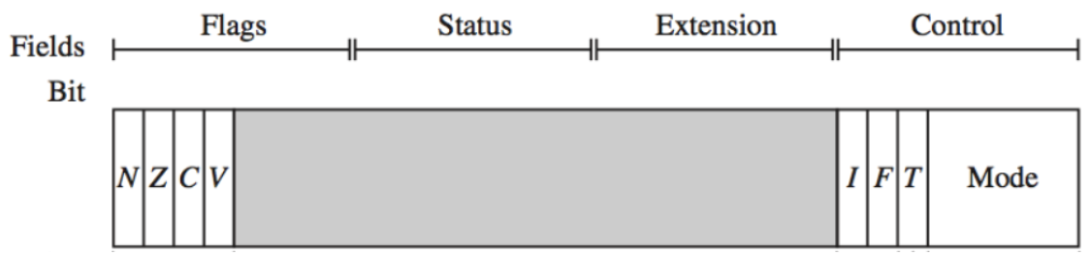

- In the CPSR register, what is the range of Control Field (in terms of bit positions)?
- 0-4
- 0-7
- 0-6
- 0-8

- In the CPSR register, what is the range of Extension Field (in terms of bit positions)?
- 8-16
- 8-15
- 8-20
- 8-12

- In the CPSR register, what is the range of Status Field (in terms of bit positions)?
- 10-18
- 16-24
- 16-23
- 13-21

- In the CPSR register, what is the range of Flags Field (in terms of bit positions)?
- 20-27
- 22-27
- 21-23
- 24-31

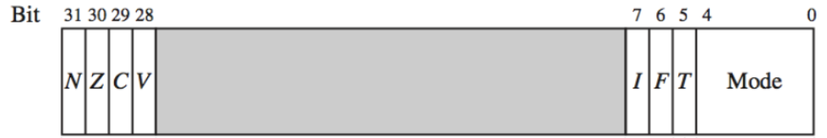

- In CPSR register, bit0-bit7 are called as _______ field?
- Control Field
- Extension Field
- Status Field
- Flags Field

- In CPSR register, bit8-bit15 are called as _______ field?
- Control Field
- Extension Field
- Status Field
- Flags Field

- In CPSR register, bit16-bit23 are called as _______ field?
- Control Field
- Extension Field
- Status Field
- Flags Field

- In CPSR register, bit24-bit31 are called as _______ field?
- Control Field
- Extension Field
- Status Field
- Flags Field
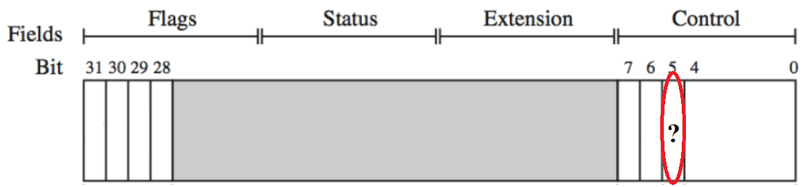
- In the above CPSR register, the bit with question mark is __________?
- O
- T
- C
- Z
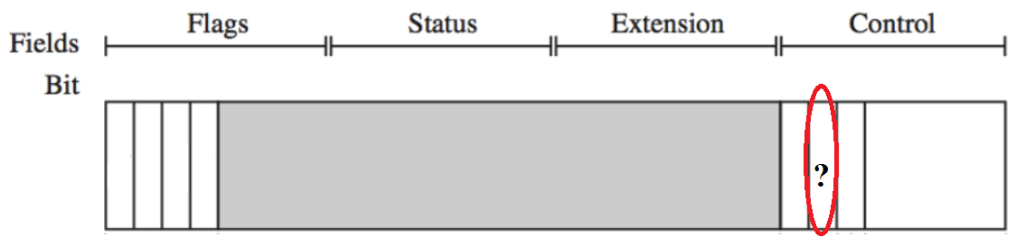
- In the above CPSR register, the bit with question mark is __________?
- O
- C
- F
- Z
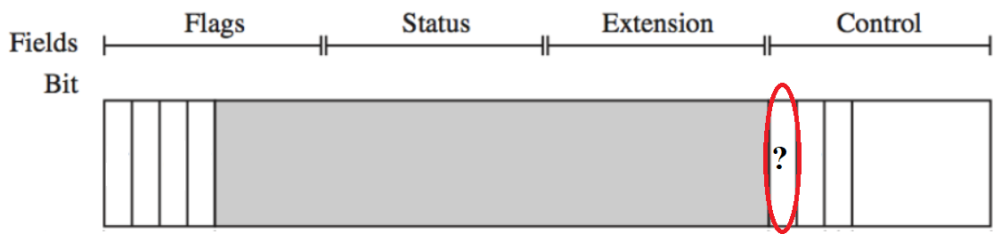
- In the above CPSR register, the bit with question mark is __________?
- I
- C
- F
- Z

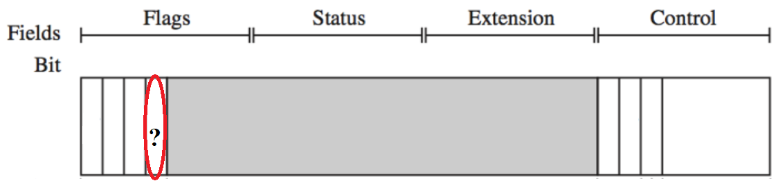
- In the above CPSR register, the bit with question mark is __________?
- I
- C
- V
- Z

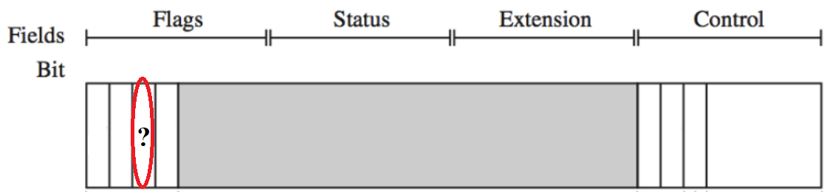
- In the above CPSR register, the bit with question mark is __________?
- I
- C
- V
- Z
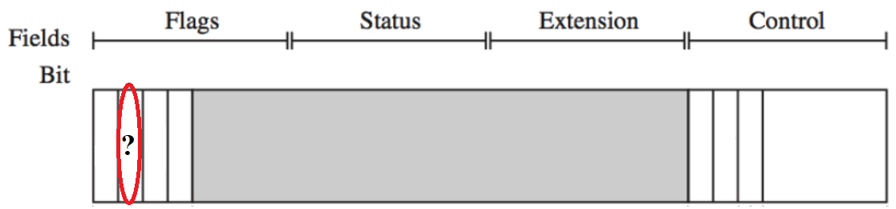
- In the above CPSR register, the bit with question mark is __________?
- I
- C
- V
- Z
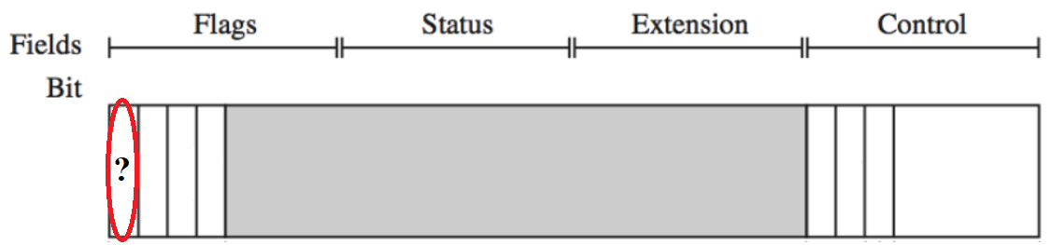

- In the above CPSR register, the bit with question mark is __________?
- I
- N
- V
- Z
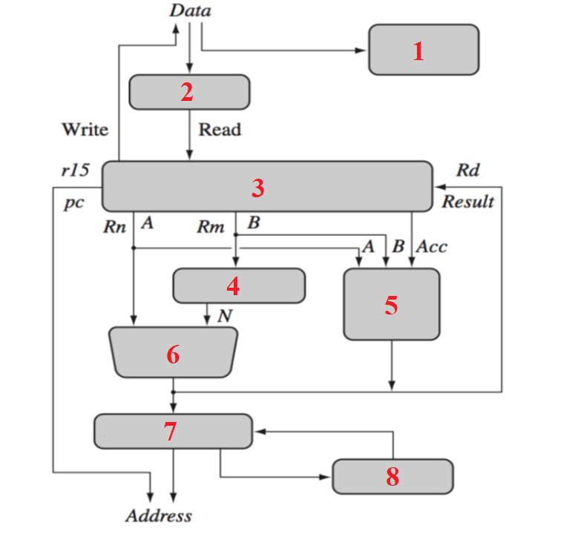
- In the above-mentioned arm core dataflow model, number 1 specifies _______ unit?
- Sign Extend
- MAC
- ALU
- Instruction Decoder

- In the above-mentioned arm core dataflow model, number 2 specifies _______ unit?
- Sign Extend
- MAC
- ALU
- Instruction Decoder

- In the above-mentioned arm core dataflow model, number 3 specifies _______ unit?
- Sign Extend
- MAC
- ALU
- Instruction Decoder
- None of the mentioned

- In the above-mentioned arm core dataflow model, number 3 specifies _______ unit?
- Sign Extend
- MAC
- ALU
- Register File

- In the above-mentioned arm core dataflow model, number 4 specifies _______ unit?
- Sign Extend
- MAC
- ALU
- Instruction Decoder
- Barrel Shifter

- In the above-mentioned arm core dataflow model, number 5 specifies _______ unit?
- Incrementer
- MAC
- Address Register
- ALU
- Instruction Decoder

- In the above-mentioned arm core dataflow model, number 6 specifies _______ unit?
- Incrementer
- MAC
- Address Register
- ALU
- Instruction Decoder

- In the above-mentioned arm core dataflow model, number 7 specifies _______ unit?
- Incrementer
- MAC
- Address Register
- ALU
- Instruction Decoder

- In the above-mentioned arm core dataflow model, number 8 specifies _______ unit?
- Incrementer
- MAC
- Address Register
- ALU
- Instruction Decoder

- In the above-mentioned arm core dataflow model, number 8 specifies _______ unit?
- Incrementer
- None of the mentioned
- Address Register
- ALU
- Instruction Decoder

- In the above-mentioned arm core dataflow model, number 7 specifies _______ unit?
- Incrementer
- MAC
- None of the mentioned
- ALU
- Instruction Decoder

- In the above-mentioned arm core dataflow model, number 6 specifies _______ unit?
- Incrementer
- MAC
- Address Register
- None of the mentioned

- In the above-mentioned arm core dataflow model, number 5 specifies _______ unit?
- Incrementer
- None of the mentioned
- Address Register
- ALU
- Instruction Decoder

- In the above-mentioned arm core dataflow model, number 4 specifies _______ unit?
- Sign Extend
- MAC
- ALU
- Instruction Decoder
- None of the mentioned

- In the above-mentioned arm core dataflow model, number 1 specifies _______ unit?
- Sign Extend
- MAC
- ALU
- None of the mentioned

- In the above-mentioned arm core dataflow model, number 2 specifies _______ unit?
- None of the mentioned
- MAC
- ALU
- Instruction Decoder

- Map the operating modes of ARM7 with their configuration values to stored in CPSR control field.
Operation Mode Mode Bits
USR 11111
FIQ 10000
IRQ 11011
SVC 10001
ABT 10111
UND 10010
SYS 10011

- The 32-bit CPSR register is divided into 4 fields namely :
___________ field , symbolized as ____,from bit 0 to bit ___.
___________ field , symbolized as ____,from bit 0 to bit 15.
___________ field , symbolized as ____,from bit 16 to bit 23.
___________ field , symbolized as ____,from bit 24 to bit ___.

- ARM7 Core uses ________ stage pipeline.
- ARM 7 Core uses ________ mapped i/o for addressing peripheral SFRs.
- I/O peripherals are ___________ mapped devices with Interrupt Support(IRQ & FIQ).
- ______________ means overlapping various stages of an instruction cycle to improve performance.

